Contact: Wesley Pomatto FOR IMMEDIATE RELEASE
Tel: 212- 334- 6865
Email: press@leelany.com

SHIVAN & NARRESH: LAUNCHES HANDBAGS

New York, NY – April 5, 2011 SHIVAN & NARRESH, innovative and quality driven swim wear line, launches their luxurious and sophisticated handbags complementing their swim, ready to wear and jewelry.

Known for their flawless lines, undisputed eye to detail and utter sophistication, SHIVAN & NARRESH dazzle with their forward and inventive bags. From muted tones to bold shades of coral, melon and turquoise, their handbags adorn this season's collection magnificent palette, completing the look for the ultimate resort wardrobe.

The handbags are constructed in leather and lined with swimwear fabrics remaining unique and sophisticated. They are the perfect complement to any wardrobe transitioning from day to eveningwear. SHIVAN & NARRESH offers a selection ranging from simple yet forward clutches to oversized travel totes with thoughtful touches that combine only the finest leathers and superior craftsmanship.

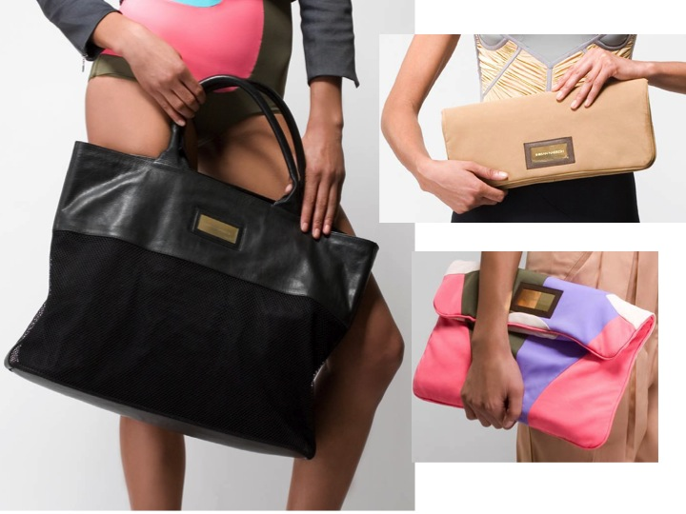

LEELA 580 Broadway, Suite 711 New York, NY 10012

